Case 14-AM,C-Costa Rica-Guanacaste-Nicoya-Figure-Female-Whistle-500–1000 CE

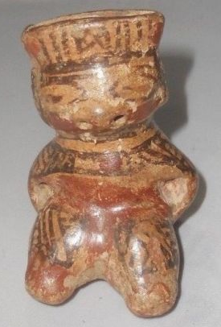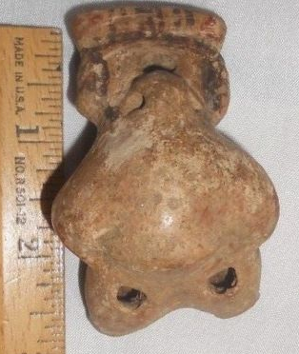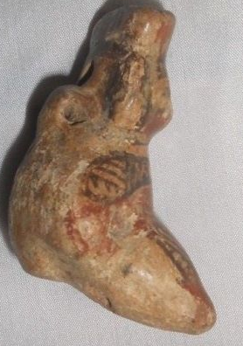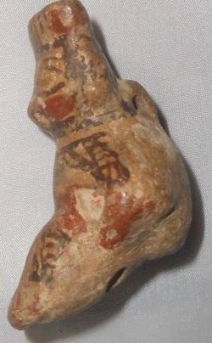

**Formal Label:** Costa Rica, Guanacaste­-Nicoya Culture, Seated Female Ritual Specialists with Shamanistic Powers.

**Display Description:** This polychrome female figure has linear and geometric body art and tattoos covering her shoulders and chest. She is posed seated suggesting an elevated social rank, and with her eyes closed as if in a trance this suggests that she is one of the ritual specialists with shamanistic powers. This figure is also a whistle and it may have been used to call those who were involved in meditative exercises.

**Accession Number:**

**LC Classification:** F1545.3.A7

**Date or Time Horizon:** 500–1000 CE

**Geographical Area:** Linea Vieja area, Costa Rica

**Map:** after http://www.hiltonpond.org/images/CR08pMapGuanacaste01Big.jpg

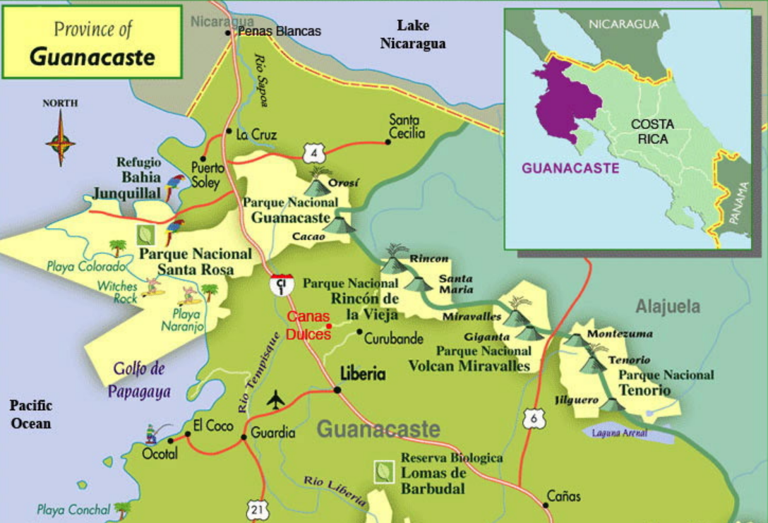

**Cultural Affiliation:** Guanacaste­-Nicoya

**Media:** terracotta, clay slip, red and black pigment.

**Dimensions:**

**Weight:**

**Condition:**

**Provenance:**

Discussion:

This elaborately-painted, burnished and carefully hand-modeled seated female nude ceramic figure is portrayed with polychrome brown-on-cream-colored linear and geometric body art and tattoos covering her shoulders and chest. She is posed seated (suggesting an elevated social rank) with arms akimbo, hands resting on her torso with legs extended. She appears to be in a trance state with her eyes closed. There are five vent-holes; two at the nose, two at the femurs and one at the cervical base of the neck. Two suspension holes made this an amulet.

Guanacaste-Nicoya archaeological periods follow the periodization of Lower-Central America (Lange 1996) in six periods that spanned 12,000 BCE-1550 CE/AD. This polychrome ceramic comes from **Period V** (AD 500-1000) in which there was a return to exploitation of marine resources, expanding habitations, and the development of Guanacaste-Nicoya polychrome ceramics of which this is an example in the Papagayo style: a cream-colored ceramic with polychrome motifs, which was widespread after 700 CE/AD. This ceramic with the figure’s eyes closed as if in a trance suggests she is one of the ritual specialists with shamanistic powers. It was probably placed in a grave in the Linea Vieja region where juxtaposed graves have stone-lined rectangular walls and floors that have preserved many ceramics in excellent condition (Stone 1972: 27).

The eminent Costa Rican historian [Carlos Meléndez](https://en.wikipedia.org/wiki/Carlos_Mel%C3%A9ndez_Chaverri) took note of the unusual location of the *templo colonial* in the urban core of the city and, based on Oviedo's brief description of the indigenous community, hypothesized that the church had been built atop the indigenous sacrificial mound. Meléndez's hypothesis fits the known Spanish pattern of direct superimposition of Catholic politico-religious structures on indigenous structures such as [pyramids](https://en.wikipedia.org/wiki/Pyramids) in Mesoamerica and Andean South America, or [kiva](https://en.wikipedia.org/wiki/Kiva) structures in the U.S. Southwest. In short, Meléndez argued that the location of the colonial church is not merely an aberration from the common Iberian pattern of facing the plaza but is coincident with the location of the sacrificial mound in the northeastern corner of the plaza of indigenous Nicoya as described by Oviedo in 1529.[[8]](https://en.wikipedia.org/wiki/Nicoya#cite_note-8)

Archaeological excavations were conducted in and around the city of Nicoya in the early 1990s to test these theories and to better understand how the indigenous community was transformed into a colonial town.[[9]](https://en.wikipedia.org/wiki/Nicoya#cite_note-9) Excavations in the center of Nicoya failed to produce any evidence of a substantial pre-Columbian presence in the city's center. Investigations into the surrounding valley failed to identify unequivocally a single site as the probable home to Nicoya. However, several large (5–10 hectare/12–24 acre) archaeological sites were in similar ecological niches throughout the valley. They are situated along river and stream banks at the point where streams leave the hills that surround the valley and cross the undulating valley floor.